BHARATI VIDYAPEETH’S COLLEGE OF ENGINEERING FOR WOMEN

FDP ON

“RESEARCH OPPORTUNITIES IN SUSTAINABLE DEVELOPMENT USING GIS TECHNOLOGIES”

SPONSORED BY AICTE TRAINING AND LEARNING (ATAL) ACADEMY

11 NOVEMBER 2024

Report on Industry Visit

Location: Maharashtra Remote Sensing Application Centre, Pune.

Resource Person: Dr.Sanjay Patil
Sr. Scientist,MASAC, Pune
Date: 14/11/2024
Dr. Sanjay Patil’s vivid explanation of GIS and remote sensing turned the session into a highly enriching experience. MRSAC, working alongside the Maharashtra Planning Department, has expanded its reach with new centers in Mumbai (2013) and Pune (2014) to streamline operations and ensure timely project outcomes. It actively promotes skill development by conducting soft skills and technical training for government personnel, administrators, NGOs, and university students. By leveraging an extensive digital database and advanced tools, MRSAC equips the state with key scientific resources. Celebrated for its GIS and Natural Resource Monitoring expertise, MRSAC remains dedicated to a more transparent, vibrant, and e-governed Maharashtra..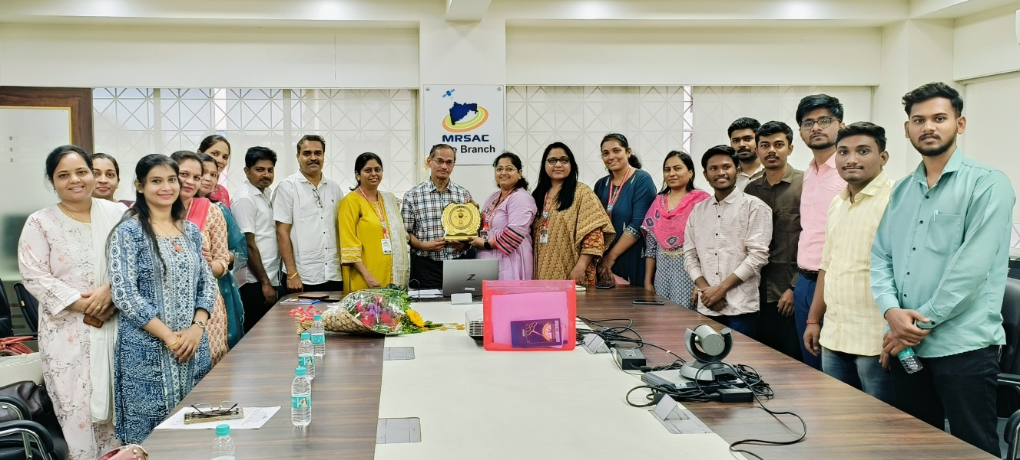
Photo: Industry Visit at MASAC,Pune.
Prepared By
Mr. Navanath Balasaheb Gadekar

